**Brooklyn torah gazette**

**For parshas behar 5782**

Volume 6, Issue 34 (Whole Number 289) 20 Iyar/ May 21, 2022

**House Votes to Bestow Medal Of Honor on Last Surviving Nuremberg Prosecutor**

**By**[**JNS News Service**](https://www.jewishpress.com/author/jns/)

[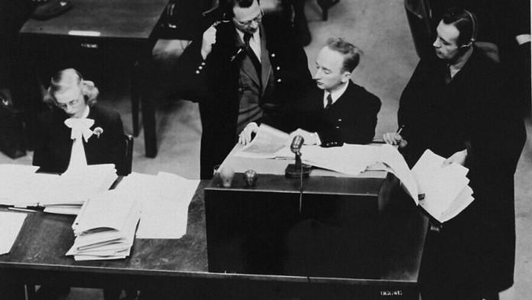](https://www.jewishpress.com/wp-content/uploads/Ben-Ferencz-Prosecutor-Nuremberg-Trials-880x495-1.jpg)

**Chief prosecutor Benjamin Ferencz presents documents as evidence at the Einsatzgruppen Trial.  -Photo Credit: United States Holocaust Memorial Museum/Courtesy of**

The U.S. House of Representatives [passed](https://www.congress.gov/bill/117th-congress/house-bill/6015/text?r=8&s=1) a bipartisan bill on Tuesday to award the Congressional Medal of Honor to Benjamin Ferencz, the last surviving prosecutor of the Nuremberg Trials.

The measure was introduced by Rep. Lois Frankel (D-Fla.), in whose district Ferencz resides.

“In this day of partisan conflict, this is a rare show of bipartisanship with 296 co-sponsors from both sides of the aisle,” Frankel stated on the House floor on Tuesday. “Mr. Ferencz is 103 years old, and to this day is a tireless advocate for the rule of law and international justice. I have met Ben Ferencz because I am blessed to say he is my constituent in Delray Beach, Fla. And he remains very alert and very humble.”

Ferencz, who was honored earlier this year by the State of Florida, was born in Transylvania in 1920. He moved to the United States with his parents before his first birthday. He was only 27 when served as a Nazi prosecutor after the end of World War II.

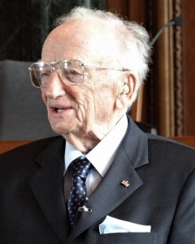

**Benjamin Ferencz, Aug. 9, 2012.**

“Nearly 80 years after the conclusion of these trials we meet here, during Jewish-American history month, after having just celebrated Israel’s Independence Day and observing Yom Hashoah, the day set aside for Jews to remember the Holocaust. It is important to recognize that we are still fighting an ongoing battle against racism, anti-Semitism and Holocaust denial in this country and around the world,” said Frankel.

She said that now “we are witnessing the horror, the inhumanity of [Russian President Vladimir] Putin’s war on Ukraine, so the timing for this bill has never been more important because Mr. Ferencz inspires us to stand up to the cruel barbarians of the world.”

“Mr. Ferencz said it best: ‘Nuremberg taught me that creating a world of tolerance and compassion would be a long and arduous task.’ His lifelong philosophies of ‘law not war’ and ‘never give up’ were quoted recently by Ukraine’s ambassador,” continued Frankel. “Today, in a bipartisan fashion, we’re going to recognize this magnificent man committed to justice, peace and human dignity with the Congressional Gold Medal.”

*Reprinted from the May 12, 2022 email of The Jewish Press.*

**Rav Avigdor Miller**

**On The Evil Eye**



**QUESTION:** **How should we understand the principle of ayin horah, the evil eye? And how do we avoid it?**

**ANSWER:** It was explained here once but I’ll explain it again. What is the evil eye? The evil eye is as follows: If you are proud of your possessions and you practice ostentation – you display your wealth or your success – then you cause a certain sorrow to other people who don’t have that success.

That is why Jewish mothers who have a brood of a lot of children, they make it their business that when somebody comes in to the house, they shoo the children out. The visitor may be a childless person or somebody who doesn’t have that much nachas; why should he be pained to see how successful you are in building your family?

Now, you have to know that even though it’s not your fault – on the contrary you are doing a great thing by raising a big family — nevertheless Hakodosh Boruch Hu takes into account the distress of every individual. And it doesn’t mean that there will be some drastic action but there could be some kind of penalty for causing distress to people.

And that is why it is always good to cover up your success. Don’t display your wealth with expensive diamonds, expensive necklaces; you can never know what is going to happen. Maybe Hakodosh Boruch Hu will cause a bum to come along and snatch it off of you. And that would be the easiest way to get away with it! Sometimes a physician might have to take it off of you in the operating room.

And so it’s always good not to display your success. Try to be as plain as you can. That is why it is good for wealthy people to teach their children to live plainly; not to give them too much money to spend; and they should try to act like people of the poor. You wealthy people, see to it that your children are always like poor children.



They shouldn’t have things to display and come among other children in the yeshiva and they show expensive watches or expensive toys to others and it hurts the poor boy or poor girl who can’t afford it. And Hakodosh Boruch Hu doesn’t keep quiet. And that is ayin horah; that is a bad eye, because people look at you with an eye and they feel bad and Hakodosh Boruch Hu will take some action. That is why it is so important.

Now, the things that people do to ward off ayin horah are all foolish things. The best way is not to be ostentatious, not to display your success. But if you are displaying it, it’s not going to help you to put a piece of garlic in your pocket.

*Reprinted from May 2, 2022 email of Toras Avigdor. Adapted from Tape # 408.*

**The True and Important Lesson to Jews About the Allowing the Land to Rest**

**From the Talks of the Lubavitcher Rebbe**

**Rabbi Menachem Mendel Schneerson, Zt”l**

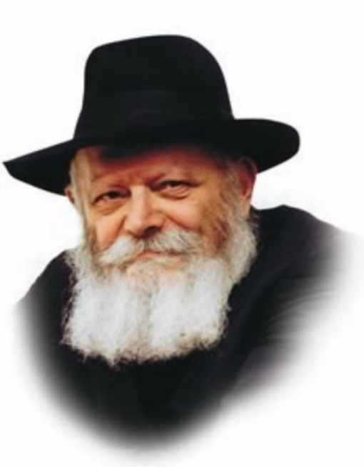

In this week's Torah portion of Behar, we read, "Six years you shall sow your field, and six years you shall prune your vineyard and gather in its fruit. But in the seventh year there shall be a Sabbath of rest to the land, a Shabbat for the L-rd." The year of shemita is a "Shabbat for the L-rd."

Commenting on this verse, Rashi explains that "Shabbat for the L-rd" means "for the sake of G-d." In other words, the practice of allowing the land to lie fallow in the seventh year must be done solely because it is a Divinely-ordained mitzva.

At first glance, allowing the land a periodical rest appears to be a natural means of rejuvenating the earth. It is a well-known fact that not cultivating the land for an entire year serves to enrich its soil and improve the quality of its future yield.

Nonetheless, the Torah demands that we not keep shemita for the purpose of land improvement. The only reason we allow the land to rest is "for the sake of the L-rd," for G-d has so commanded us.

When Jews refrain from working the land in the seventh year, they thereby attest to G-d's mastery over the world. Observing shemita demonstrates openly that our involvement in the pursuit of a livelihood has not caused us to forget the Creator.

The mitzva of shemita trains us to remember that no matter what we do, everything in life is "for the sake of G-d." Even those things which are considered "natural," i.e., eating, drinking, sleeping and going to work, must be done purely for the sake of heaven.

When a Jew eats, he must do so "for the sake of G-d." He consumes food in order to be strong and healthy, to be able to perform more of G-d's mitzvot.

When a Jew sleeps, he sleeps "for the sake of G-d." He knows that the body must rest to recoup its strength, that he be fully alert and capable of observing the commandments.

Such must be the attitude toward every detail in life: We must always remember that all facets of existence are "for the sake of G-d."

Acting in such a manner brings down G-d's blessing, as it states, "And I will command my blessing upon you," ensuring that G-d will grant us only goodness from His full, open and holy hand.

*Reprinted from the Parshat Behar 5757/1997 (Issue 469) edition of L’Chaim Weekly, a publication of the Lubavitch Youth Organization in Brooklyn, NY. Adapted from Likutei Sichot, volume 7.*

*\*\*\*\*\*\*\*\*\*\*\*\*\*\*\*\*\*\*\*\*\*\*\*\*\*\*\*\*\*\*\*\*\*\*\*\*\*\*\*\*\*\*\*\*\*\*\*\*\*\*\*\*\*\*\*\*\*\*\*\*\*\*\*\*\*\**

**If your brother becomes impoverished and sells part of his possession, his relative who is closest to him shall come and redeem his brother's sale (Lev. 25:25)**

This law is stated in the singular, while the previous laws are stated in the plural. When one is affluent and successful, he finds himself surrounded by friends and associates who enjoy his company. But if his fortunes take a downturn, he may find himself very much alone and in need of help. The Torah tells us that each person should consider himself to be the sole individual capable of coming to his brother's aid. (Alshich)

*Reprinted from the Parshat Behar 5757/1997 (Issue 469) edition of L’Chaim Weekly,*

**Rabbi Berel Wein on**

**Parshat Behar 5782**

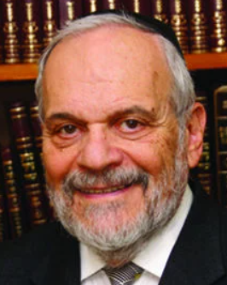

This week's portion creates an eternal connection between Mount Sinai, the Jewish people, and the Torah itself. The fact that the Torah emphasizes its eternal association with Mount Sinai is meant to teach us important lessons regarding Judaism and Jewish life.

There are grand and majestic mountains that dot our planet. They are awe-inspiring in their height and strength, and they tower over us, making us feel puny and insignificant when standing at their base. I remember that when I was able to visit Mount McKinley in Alaska, a mountain which rises vertically more than 20,000 feet above the plane from which it emanates, the feeling of tension was so overpowering that people in our tour group burst into tears. The mountain blocks out the sun and creates its own weather.

However, the Torah was not given to human beings on Mount McKinley or Mount Everest or any of the other great mastiffs that exist in our world. Midrash teaches us that Mount Sinai was and is a relatively low mountain. The rabbis derived from this the emphasis on and the requirements of humility. Arrogance and godly values do not coexist. So, even though Mount Sinai is a mountain, it is a low mountain, one that can be scaled and conquered. And the achievement of climbing that mountain will not produce fanfare or notoriety.

If the Torah had been granted on Mount Everest it would be unreachable for almost all human beings. It was given on Mount Sinai, to emphasize that it is accessible to all, and that even though it is a mountain, it is one that can and must be scaled, to achieve the eternity that it promises human beings.

From the top of a mountain, one has a majestic view of the surrounding area. A mountain peak provides us with perspective, and the ability to judge the world from an overview as an observer, even though we are participants. Without that overview, is very difficult to make sense of life, or to have any personal sense of serenity or peace.

The prophet tells us that the wicked are like the raging sea whose waves constantly batter the shoreline but are always limited. Mountains, when appreciated, give us the blessings of unique wisdom, patience, and a sense of optimism and hope in our lives, no matter how bleak events may be, or how worrisome situations are.

Our father Abraham founded the Jewish people and brought "godliness" down to our earth. He saw that measure of godliness as being in the form of a mountain. His son, Isaac, would modify it so that it would become like a field. And his grandson Jacob would see it as being a house. But all of these characteristics still remain within Judaism. Mount Sinai exemplifies the mountain that Abraham saw.

Life is never an easy climb, but climb it we must, to be able to stand at its peak, and truly observe life in society in a measured and wise way.

******************************************************************

**Do not take from him interest and increase, and let your brother live with you (Lev. 25:36)**

When a person lends money on interest, he wants the days to pass as quickly as possible, because with each passing day he makes more money. When a person borrows money on interest, he feels the opposite way, that time should go slowly, because with each passing day he owes more money. They have a different outlook on time, which would not be the case with an interest-free loan. Thus, the Torah says, "your brother will live together with you," with the same outlook on time. *(Alshich)* *From Vedibarta Bam by Rabbi Moshe Bogomilsky*

**How a Smile Can Save a Life**

**By Sara Esther Crispe**



I could tell that they had no idea who I was. I tried to remind them about the Shabbat meals I had eaten at their house so many years ago. But to no avail. They really just didn't remember me. I wasn't insulted. I often bump into people I met years ago, without being able to place them or recollect how we knew each other. But in this particular case it was funny, because not only did I remember this family in great detail; they were actually responsible, to a great degree, for my life today. You see, about 18 years ago, one of their daughters was having her bat mitzvah. For some reason, the parents asked if I would come and speak to her group of friends.

In doing so, I realized how much I loved public speaking, and began thinking that it was something I wanted to do with my life. At the time, the only public speaking I had done was teaching 12th-grade high school, and that was certainly not the kind of reinforcement I needed to choose it as a career.

But showing up at that bat mitzvah, speaking to those girls and having them laugh with me, and then tell me that I inspired them . . . that was something that changed my life. If only we could know the things we said or did that might have altered someone's life for the better. If only we could know when we were the right person at the right time who said the right thing.

So often, we go through our days thinking we accomplished nothing, having no c l u e t h a t t h e p e r s o n w e complimented or smiled at might have needed that smile more than we could ever imagine. The Baal Shem Tov, the founder of the Chassidic movement, taught that we come into this world for our entire lifetime just to do a favour for another.

There is even a cute little ditty that the kids sing with this message. Just one favour. Really? A whole lifetime and that could be the sum total of it all? And yet, maybe that one favour changed a life? Inspired a life? Saved a life?

At a mental health awareness event a few years ago, I heard a man describe his suicide attempt, in which he jumped off the Golden Gate Bridge in San Francisco. Few who have made that 220-foot jump have lived to tell their stories. Actually, only 2 percent of those who jump survive. But this man was one of the fortunate ones. He spoke to us about the power of depression, about the intense loneliness one can feel. The night he made the decision to die, he rode a public city bus to the bridge. He was the last one off the bus at the last stop. As he exited, he looked at the bus driver, desperate for a kind word. But the bus driver never even bothered looking at him. This young man then made a promise to himself that if anyone smiled at him or asked how he was doing, it would prove to him that his life was worthwhile, and he wouldn't jump. But no one did.

At one point a couple even asked him to take their picture, but, consumed with their own lives, they didn't pick up on the fact that minutes later their picturetaker would be attempting to take his own life. Feeling that no one in the world cared about him and that he had nothing to live for, the man climbed onto the railing of the bridge and jumped.

The second his feet left the bridge, he deeply regretted his decision. “I don't want to die. I don't want to die,” he prayed the entire way down. Miraculously, he didn't. He broke just about every bone in his body, but he lived. Until the rescuers reached him, sea lions swam under his broken body, keeping his head above water. His story is amazing.

But even more ex traordinary than his personal survival is the promise he made to himself before he jumped. One smile could have saved his life. We could have been that one person on the bridge. Or that person on the bus with him. We could have offered a smile, or a “have a good night.” And had we offered that smile, we would have gone on our way, having no idea what that small act accomplished. That could have been the favour that the Baal Shem Tov was speaking about.

When I met this family again after so many years, it was clear that the impact they had made on me was much greater than the impact I had made on them. And that was perfectly fine. I didn't need them to remember me. I just needed them to know how they influenced my life.

By giving me the opportunity to speak, they introduced me to something I love, something I have been doing professionally from that point onward. Ironically, I reconnected with this family at a Passover program where my husband and I were the keynote speakers! I felt so blessed that I was able to see this family again, that I was able to thank them for what they had given me and to let them see that they had made a huge difference in the life of someone they didn't even remember.

Having that experience reminded me that everything we do, the big things as well as the seemingly not so big, can have an impact, sometimes even a lifesaving one. So the next time we walk down the s treet minding our own business, let's take that second to look up and smile at a stranger passing by. Maybe, just maybe, that is what he is living for.

*Reprinted from the Parshat Emor 5782 email of Lamplighter.*

**“I’m Not Giving Up on You”**

**By Rabbi Yisroel Majeski**



**Rabbi Zechariah Wallerstein, zt”l**

My first Pesach program I spent with Rabbi Wallerstein in Arizona, I received a call from someone I was vaguely familiar with that her sister was coming over Chol Hamoed to join the program. I took in the news, and planned on finding the right time to have a brief conversation with her. I eventually did, though she sat still, with her eyes looking down. I knew that she was going through a difficult time.

Years later, I called the girl and asked if she could go back to that Pesach program and share with me some of her experiences with Rabbi Wallerstein. She told me the following.

**The Girl’s Story**

“I was feeling extremely empty in my life, and knew that I needed to get away from my family and my home. I was in eleventh grade and took a flight to Las Vegas and found two Jewish couples I could stay with. No one knew where I was, except my sister. My sister didn’t know what to do, so she called Rabbi Wallerstein.

“I then received a call from a man who introduced himself as Zecharia Wallerstein, but I had no idea who that was.

‘What are you doing in Vegas’? he asked me.

‘Who are you?’ I shot back, and with that, I hung up the phone.

“But Rabbi Wallerstein wasn’t going to give up easily. He called me back and said, ‘Listen, I’m booking a flight right now for you to Arizona, and you’ll come to my Pesach program and spend the rest of time here.’

‘You’re crazy!’ I said. ‘I’m not going anywhere. I came here to get away from everyone and everything, and I’m not going to your program.’ But Rabbi still wasn’t stopping. He called back yet again.

‘Listen, you’re with people who your family is not comfortable with, and you need to be elsewhere. You need to come here.’ Rabbi told me that he’d take steps to make sure I wouldn’t remain where I was, which I didn’t think he’d do, but he actually did. So, with his insistence, I took the ticket and got on the plane. I figured I’d go there for a few days, make Rabbi happy and then leave.

“I arrived at the Pesach program and I didn’t want to look at him, let alone talk to him. I was so angry at him. He gave me my own hotel room, but I still remained upset.

**Talking About the Ranch**

“Towards the end of Pesach, when I had settled in, he sat me down and began telling me about the Ranch. ‘You have to go to the Ranch,’ he said. It took me six months to finally make it to the Ranch. I got to the point where I realized that I needed the help. I was a mess at that time.

“But you don’t know how bad I was. I got kicked out of the Ranch. For that to happen, it must have been serious. The Ranch is a place filled with love and care, and to be asked to leave is no small deal. I was a troublemaker, though, but a leader as well. I would lead the other girls to follow what I was doing, and the Ranch couldn’t have it that I led the other girls to unsafe emotional places.

“So I went to a hospital for some time. Eventually I made it out, and I wanted to go back to the Ranch. But they said they were sorry that they weren’t equipped to deal with me. I called Rabbi Wallerstein and told him my predicament. There was another rehab that I wanted to go to, and so, Rabbi called them and talked to them about me getting in.

**“Never Felt So Dejected in My Life”**

“But once they heard about me and what had happened, they didn’t accept me. I had been kicked out of a lot of places in my life, but when this happened, I had never felt so dejected in my life. I got kicked out of the Ranch and another rehab wouldn’t even take me in?

“I called back Rabbi Wallerstein and told him, ‘Rabbi, if you don’t get me into a place by tomorrow, it’s done. I’m going to go back to my old life.’ Rabbi then told me the following.

‘I’m going to get you into another place, and I’m not giving up on you, because you’re my child.’ He said those words and I can’t describe to you how it went straight into my heart. I knew he really meant it. The next day he got me into a rehab in New Jersey, and that’s when my life turned around. He has been there for me ever since. I have brought to him everyone I’ve ever gone out with, he calls me before every Yom Tov and always has a good word to say. Whenever I would call, ‘Listen, you’re with people who your family is not comfortable with, and you need to be elsewhere. You need to come here.’ Rabbi told me that he’d take steps to make sure I wouldn’t remain where I was, which I didn’t think he’d do, but he actually did. So, with his insistence, I took the ticket and got on the plane. I figured I’d go there for a few days, make Rabbi happy and then leave.

“I arrived at the Pesach program and I didn’t want to look at him, let alone talk to him. I was so angry at him. He gave me my own hotel room, but I still remained upset.

**Talking About the Ranch**

“Towards the end of Pesach, when I had settled in, he sat me down and began telling me about the Ranch. ‘You have to go to the Ranch,’ he said. It took me six months to finally make it to the Ranch. I got to the point where I realized that I needed the help. I was a mess at that time.

“But you don’t know how bad I was. I got kicked out of the Ranch. For that to happen, it must have been serious. The Ranch is a place filled with love and care, and to be asked to leave is no small deal. I was a troublemaker, though, but a leader as well. I would lead the other girls to follow what I was doing, and the Ranch couldn’t have it that I led the other girls to unsafe emotional places.

“So I went to a hospital for some time. Eventually I made it out, and I wanted to go back to the Ranch. But they said they were sorry that they weren’t equipped to deal with me. I called Rabbi Wallerstein and told him my predicament. There was another rehab that I wanted to go to, and so, Rabbi called them and talked to them about me getting in.

**“Never Felt So Dejected in My Life”**

“But once they heard about me and what had happened, they didn’t accept me. I had been kicked out of a lot of places in my life, but when this happened, I had never felt so dejected in my life. I got kicked out of the Ranch and another rehab wouldn’t even take me in?

“I called back Rabbi Wallerstein and told him, ‘Rabbi, if you don’t get me into a place by tomorrow, it’s done. I’m going to go back to my old life.’ Rabbi then told me the following.

‘I’m going to get you into another place, and I’m not giving up on you, because you’re my child.’ He said those words and I can’t describe to you how it went straight into my heart. I knew he really meant it. The next day he got me into a rehab in New Jersey, and that’s when my life turned around. He has been there for me ever since. I have brought to him everyone I’ve ever gone out with, he calls me before every Yom Tov and always has a good word to say. Whenever I would call, he would say, “I’m so excited to hear your voice!” That’s a line a parent would tell a child.

**“Who Met You at the Airport?”**

But there’s something else to the story.

After she had told me everything, I asked her, “Can I ask you one question?” “Sure,” she said. “Who picked you up from the airport when you landed in Arizona?”

“Rabbi Wallerstein,” she said.

When you run a Pesach program, your head is somewhere else. There were so many people he could have asked to pick her up from the airport. But he went to pick her up, because when it’s your daughter at the airport, you don’t send someone else to pick her up; you do it yourself. Rabbi Wallerstein was known to have said that we must treat our Jewish children as our own sons and daughters. But it wasn’t just talk for him. He walked the walk. It was real. He lived that way.

When it’s your daughter, there are no excuses. You go the full length and do anything and everything to be there. Rabbi Wallerstein was such a man, and we must be that way too.

*Reprinted from the Parshat Emor 5782 of the Torahanytime.com Newsletter as Compiled and Edited by Elan Perchik*